

|  |
| --- |
| SBC335x-B1A快速操作指南 v1.0 |
| 基于TI AM335x核心平台 |
|  |

免责声明

本文档是作者对GOEMBED 产品进行实际操作和测试后，自我操作总结。由于作者水平有限，建议读者具备一定的计算机基础和基本软件操作能力，如在操作过程中，遇到疑问和错误，欢迎加QQ群(462424566)交流和建议，或发厂商技术支持邮箱进行咨询: support@goembed.com

操作环境配套说明：

|  |  |
| --- | --- |
| 硬件 | 详细介绍链接 |
| SBC3358-B1A单板机 | [c:\users\administrator\appdata\roaming\360se6\User Data\temp\1411389502416719.jpg](http://www.goembed.com/index.php/Products/detail/tpid/25) |
| 串口调试器：COM10U | [c:\users\administrator\appdata\roaming\360se6\User Data\temp\1408786855283579.jpg](http://goembed.com/index.php/Products/detail/tpid/16) |

|  |  |
| --- | --- |
| 软件 | 详细介绍链接 |
| Ubuntu版本：12.04LTS（64bit） | [http://www.ubuntu.org.cn/download/desktop](http://www.ubuntu.org.cn/download/desktop%20) |
| Linux版本：3.11.0-15-generic |
| gcc版本：4.6.3 |

### SBC3358-B1A单板机软件特性

#### 1、BootLoader版本：u-boot-2013.01.01

#### 2、内核版本：Linux-3.2.0

* LCD驱动
* LCD背光驱动
* 电阻式触摸屏驱动
* VGA驱动
* HSMMC/SD/MMC/SDIO驱动
* IIC驱动
* SPI驱动
* 音频驱动
* DMA驱动
* RTC实时时钟驱动
* 电源管理
* USB HOST/DEVICE驱动
* USB OTG驱动
* DEBUG驱动
* 以太网驱动
* TF卡驱动
* CAN驱动
* 串口驱动
* WG驱动

#### 3、交叉工具链：arm-Linux-gnueabihf-gcc

### SBC3358-B1A单板机资源分配特性

#### eMMC空间分配

|  |  |  |
| --- | --- | --- |
| Partition | Size | Description |
| BootLoader | **200MB** | **FAT32格式分区** |
| rootfs | **约1500MB** | **EXT3格式分区** |

### 一、准备工作

#### 1、硬件连接。

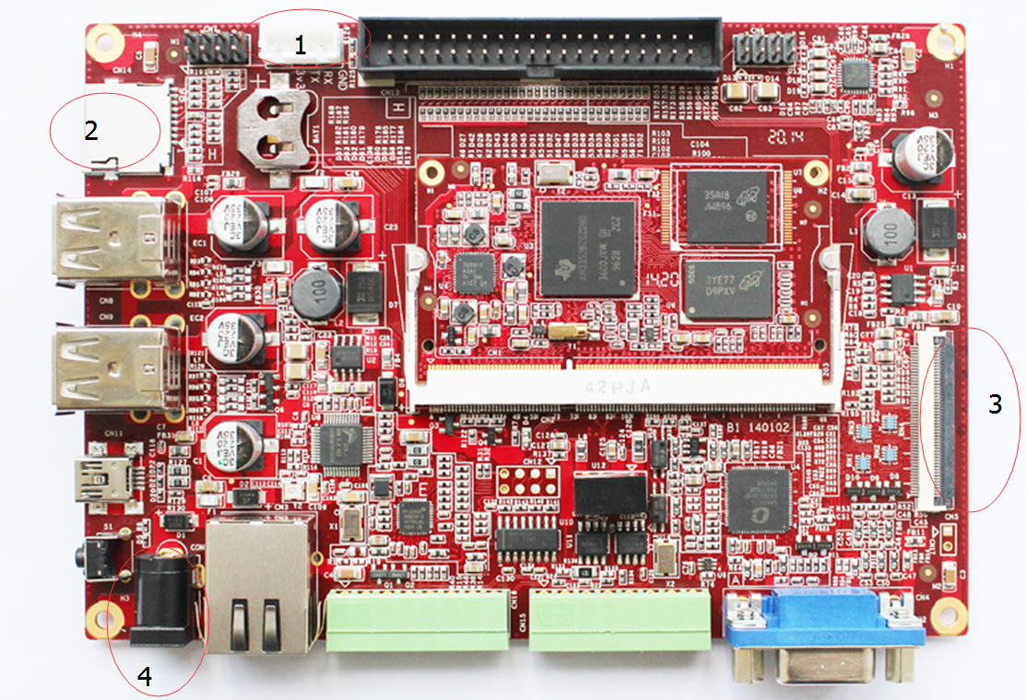

|  |  |  |  |
| --- | --- | --- | --- |
| **编号** | **描述** | **编号** | **描述** |
| **1** | 串口接口（TTL电平） | **3** | LCD液晶屏接口 |
| **2** | TF卡接口 | **4** | 连接电源适配器（12V） |

（1）、编号1处接串口线，上图从左往右插针依次为3V3，TX,RX,GND。

（2）、编号2处接TF卡，如果开发板内部eMMC已烧写系统可不接。

（3）、编号3处接LCD显示屏，不需要可不接。

（4）、编号4处接12v直流电源适配器。

#### 2、配置SecureCRT

（1）、打开SecureCRT 软件。

（2）、点击Quick Connect按钮，如图。

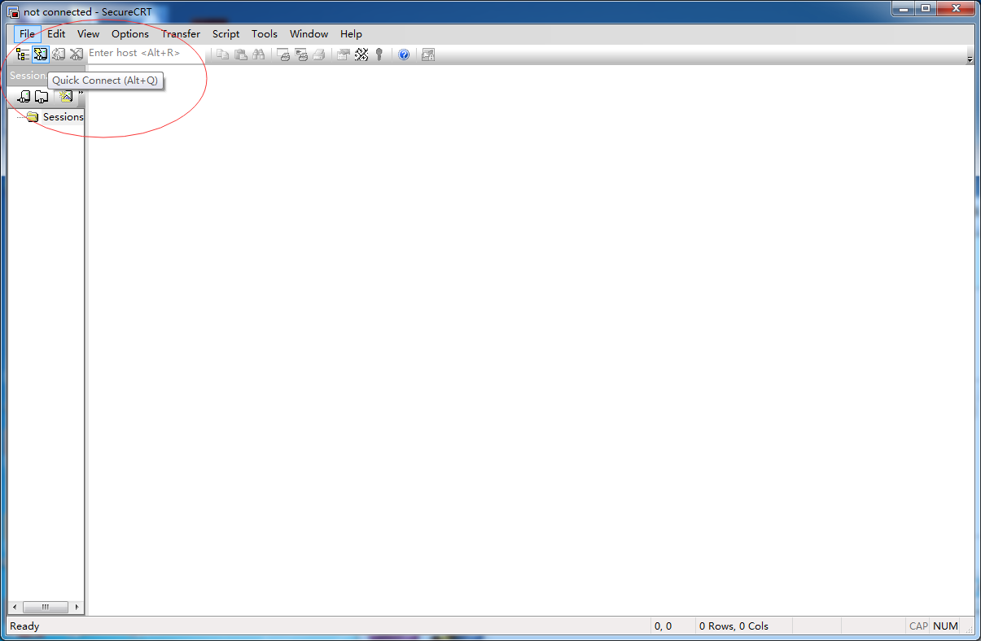

（3）、点击SSH2出现下拉菜单

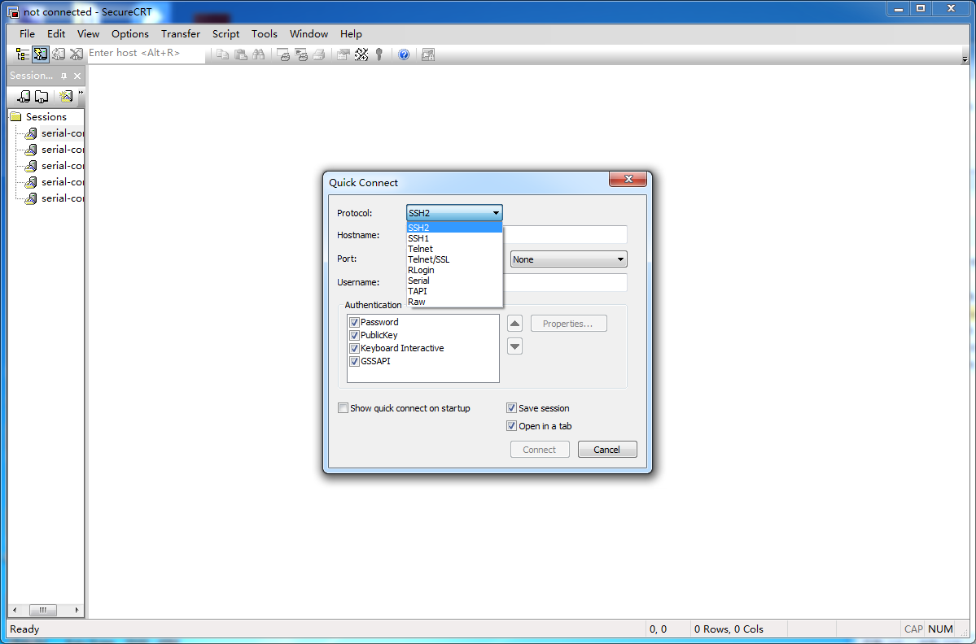

（4）、选中Serial

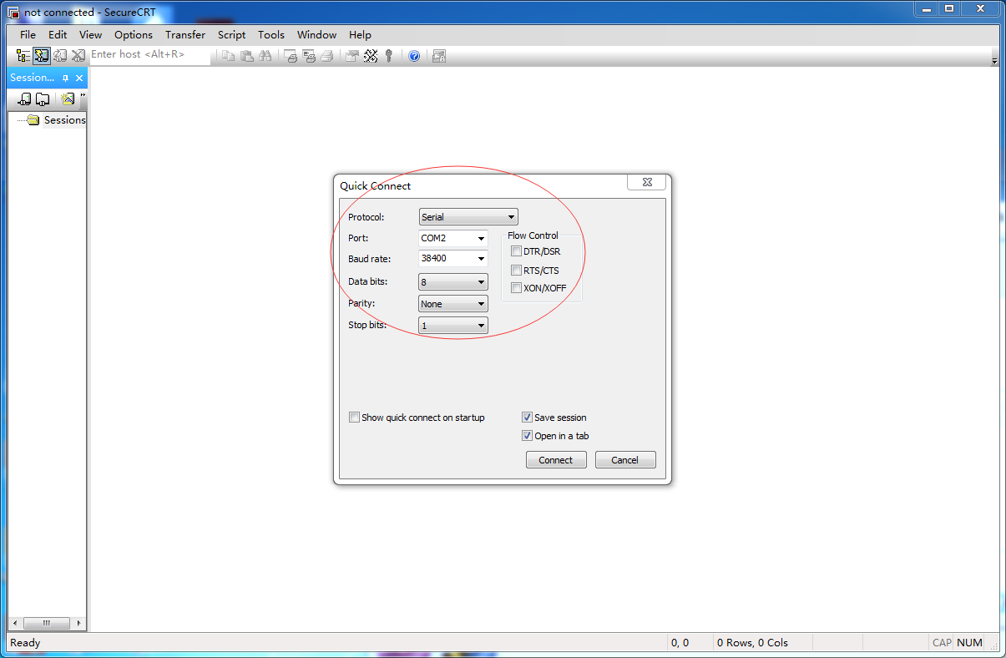

（5）、右键，我的电脑，管理。

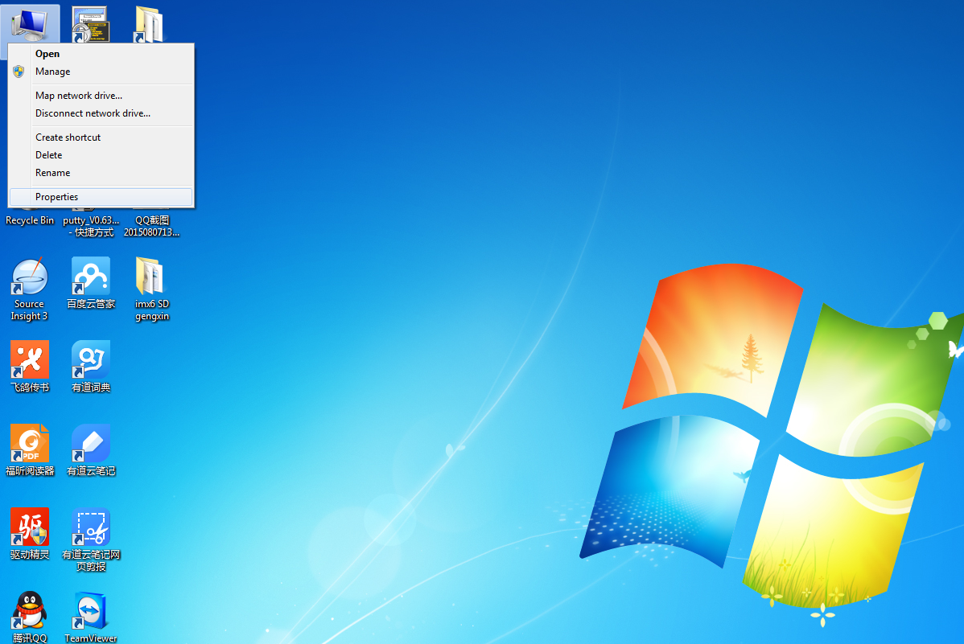

（6）、选择“设备管理器”。

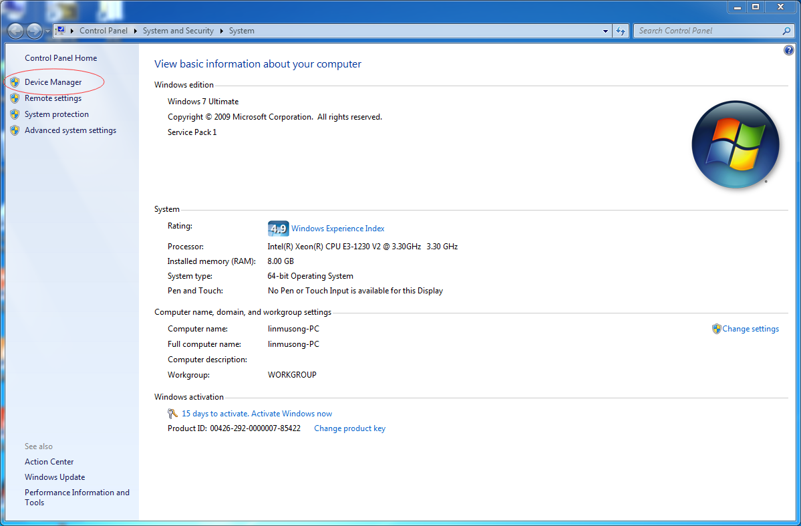

（7）点开端口，查看到自己的USB 串口号为COM3（不同的电脑不一样，根据实际情况来）

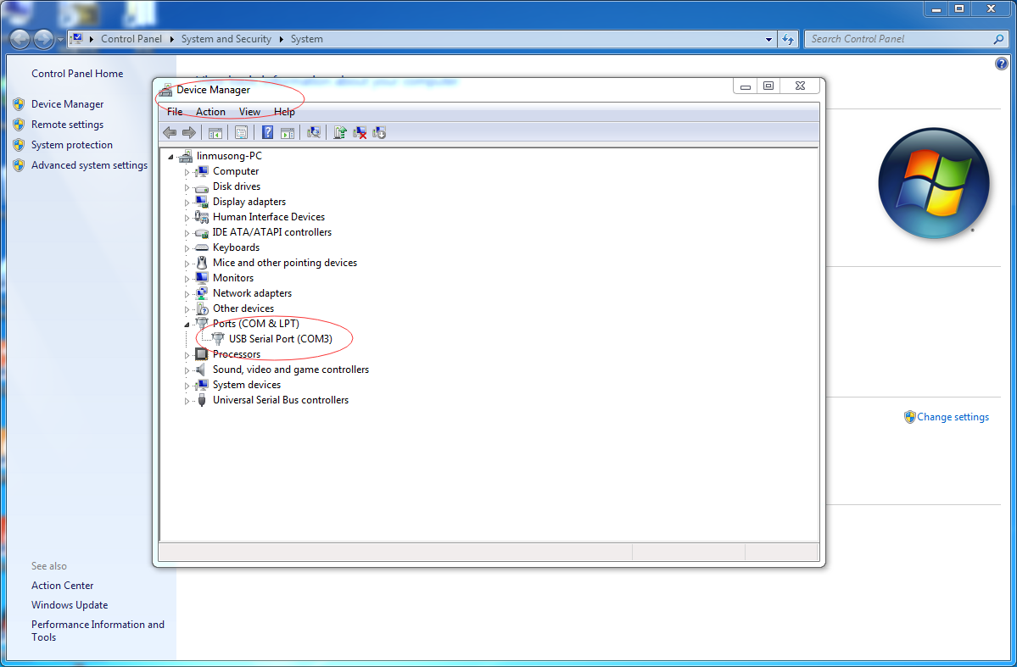

（7）、选择SecureCRT的port号为COM3，Baud rate为115200，Data bits 为8，Parity为None，Stop bits为1。

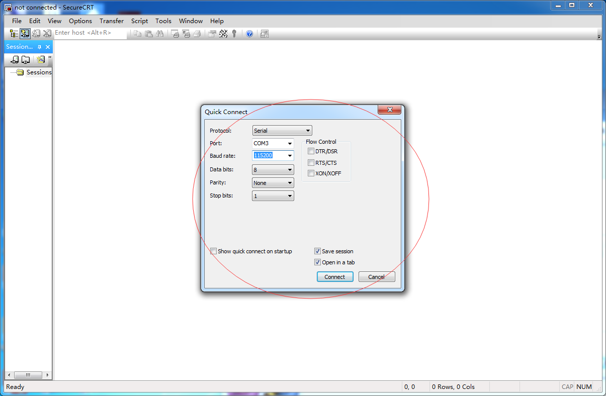（8）、点击Connect后有黑色光标在闪，同时右下角显示当前配置信息。

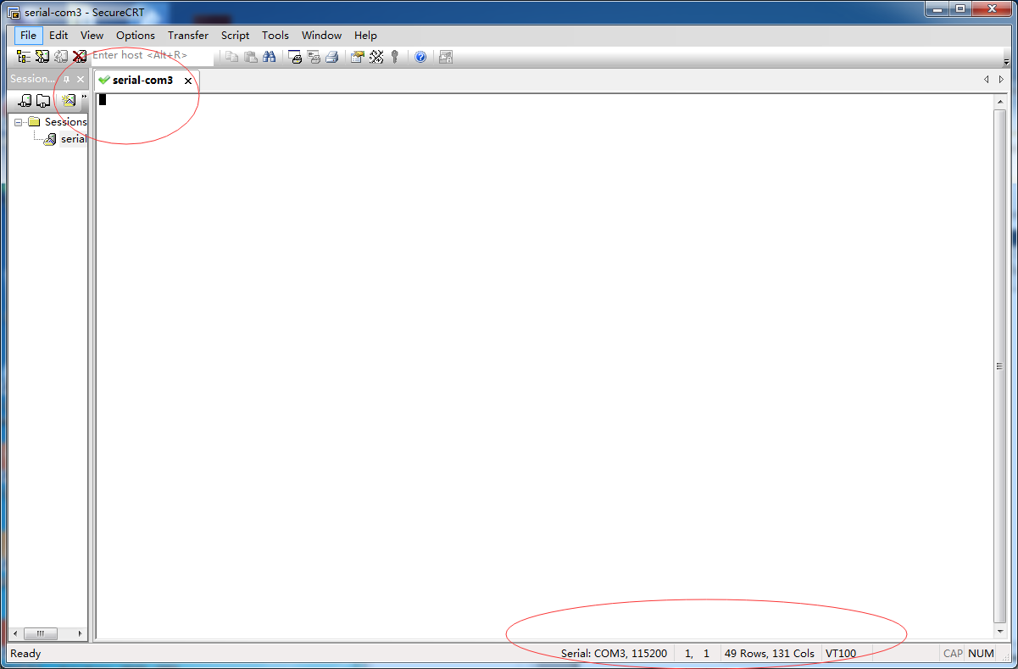

### 二、启动操作系统

注：SBC3358-B1A默认先从eMMC启动，如果eMMC中没有镜像，则会从TF卡启动，如果TF卡中也没有镜像，则串口终端会一直打印“CCCC”。当eMMC中有镜像且TF卡也有镜像时，如果这时想从TF卡启动，只要先将板子上的CN17引脚短接再上电即可从TF卡启动。

#### 1、eMMC启动系统

（1）接入串口模块，接上7寸LCD液晶屏，然后接上12V电源适配器。

（2）打开串口终端。

（3）打开开发板开关（前提是eMMC中已烧好系统）则可看到打印信息。出现如下界面，输入root可操作Linux系统。

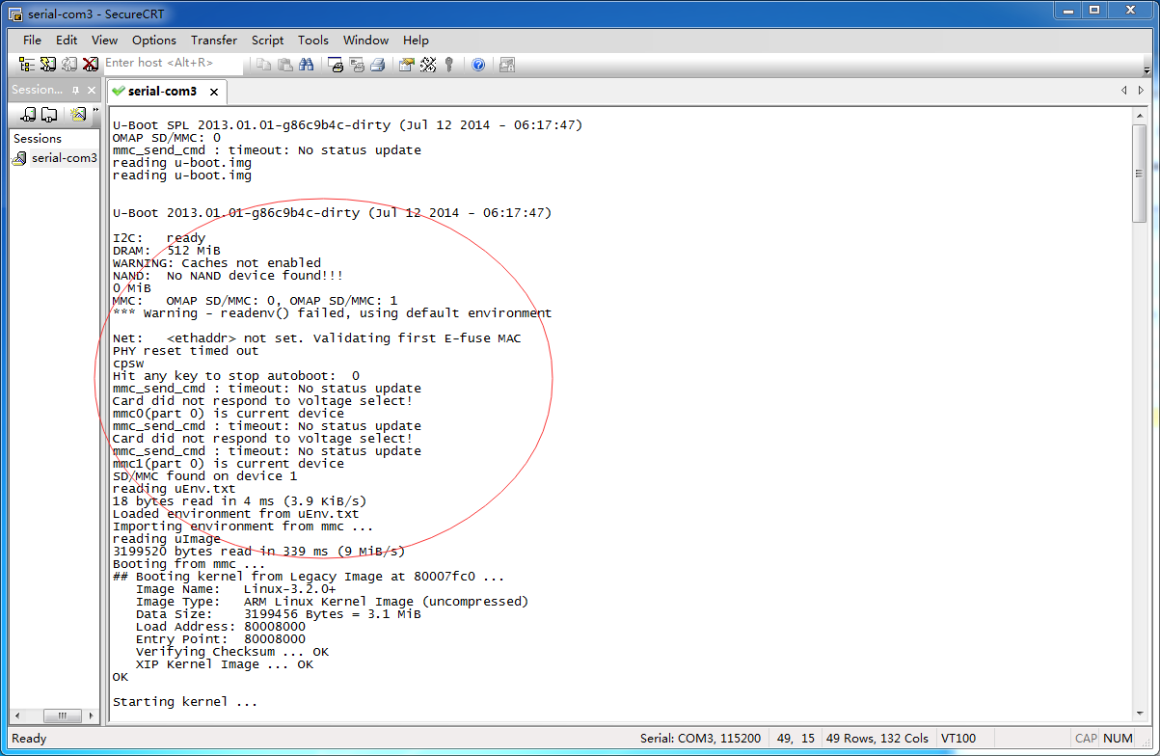

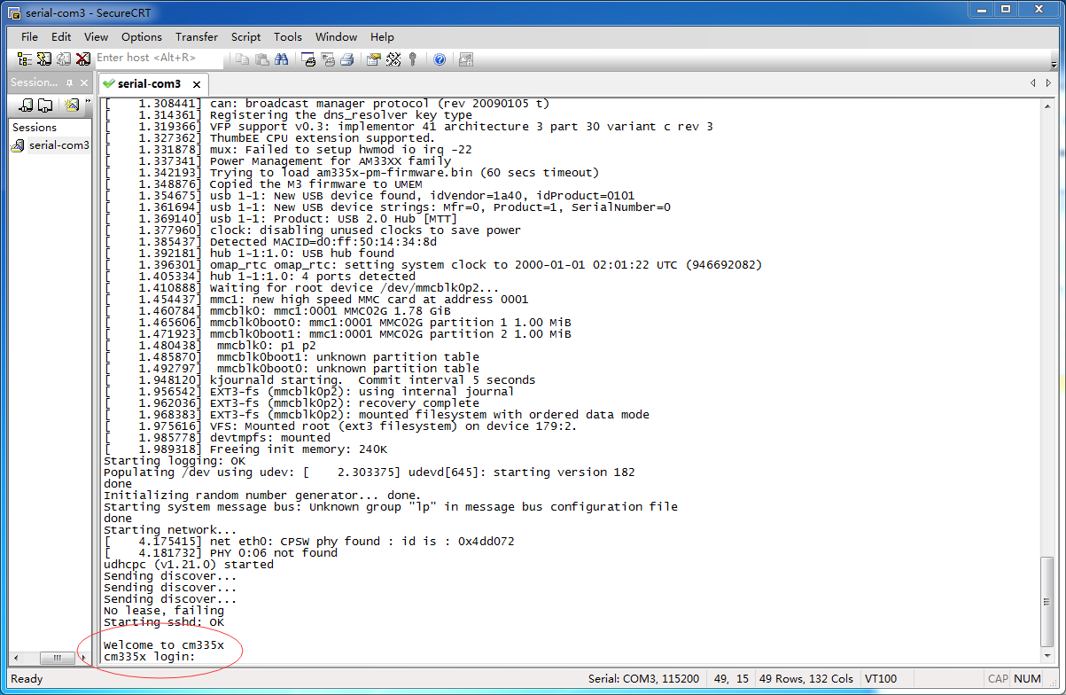

#### 2、TF启动系统

（1）将制作好Linux系统的TF卡插入卡槽。

（2）接入串口模块，接上7寸LCD液晶屏。如果eMMC中有系统但又不想从eMMC启动的话则短接CN17可改从TF卡启动（如果eMMC无系统则自动从TF卡启动），如下图所示

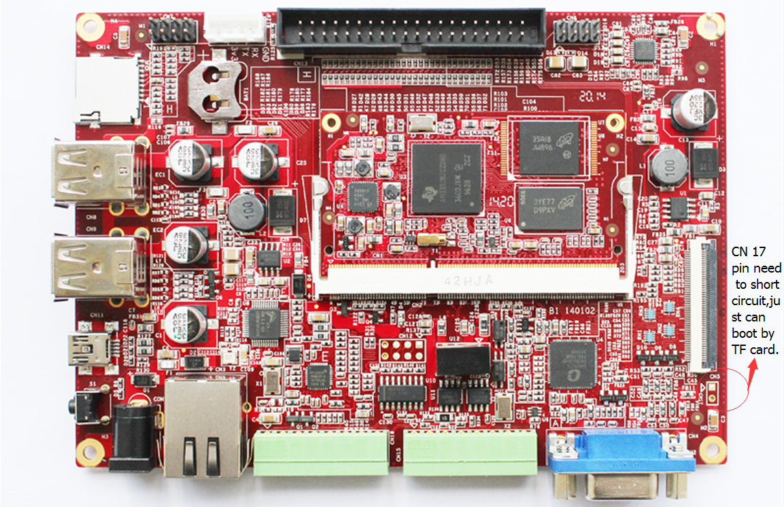

（3）终端可看到如下信息。输入root可操作Linux系统。

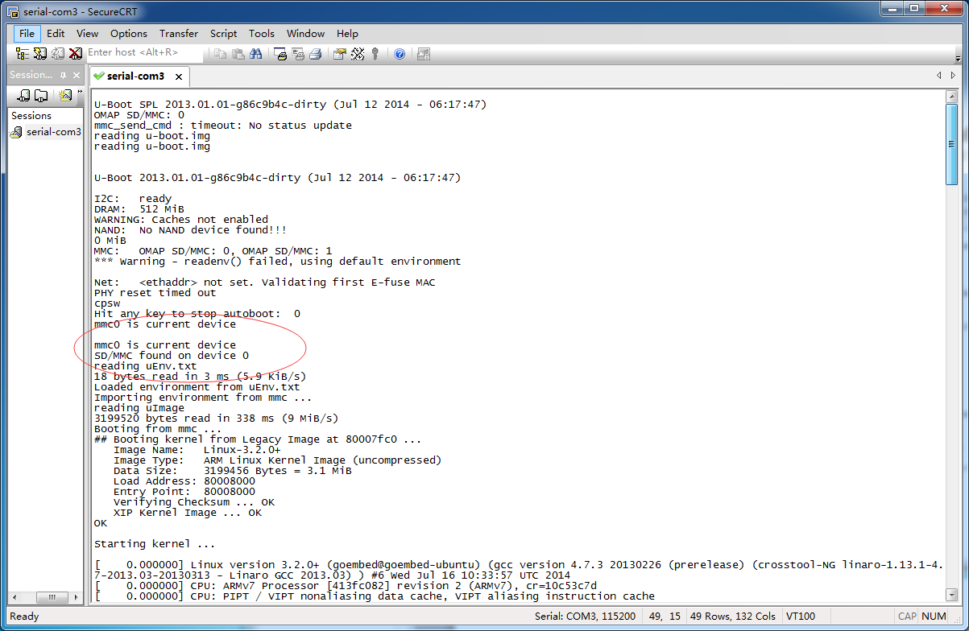

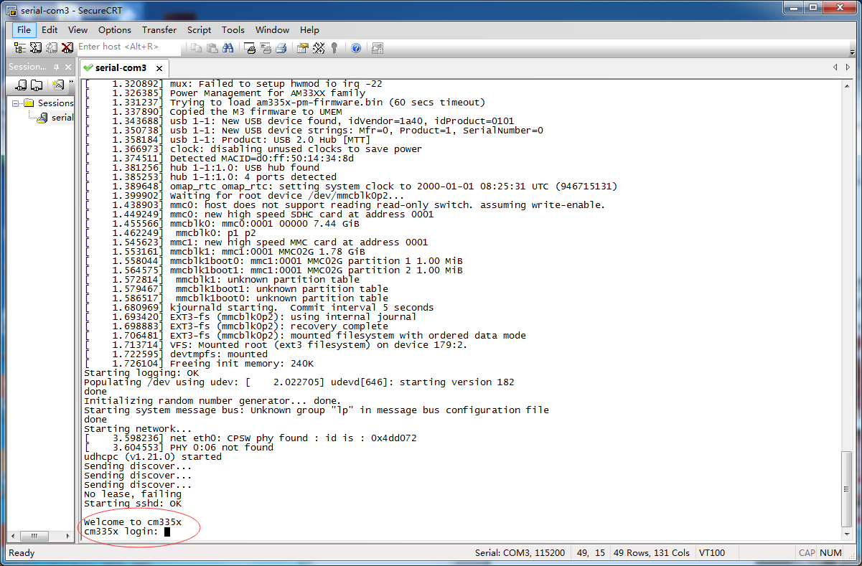

#### 3、改动屏幕参数

我们修改LCD屏的参数不需要重新编译内核，只需要修改传递的参数，也就是说通过修改uEnv.txt文件即可修改LCD屏参数。修改操作可以在终端中完成，如果uEnv.txt在TF卡中也可通过电脑来修改。

如果使用是4.3寸屏，需要修改uEnv.txt内容为dispmode=4.3inch_LCD。

如果使用是7寸屏，需要修改uEnv.txt内容为dispmode=7inch_LCD。

如果我们使用的是VGA显示，需要修改uEnv.txt 内容为dispmode=VGA。

修改完重启系统即可。

附 相关GOEMBED产品介绍

[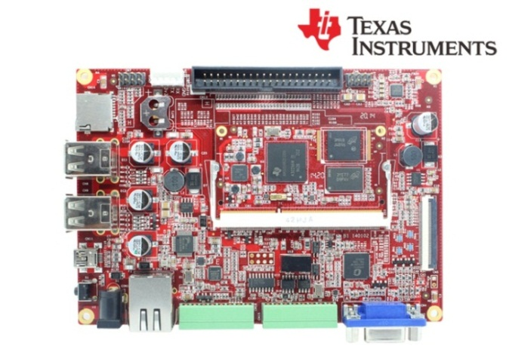](http://www.goembed.com/index.php/Products/detail/tpid/25)

*SBC335x – B1A*

[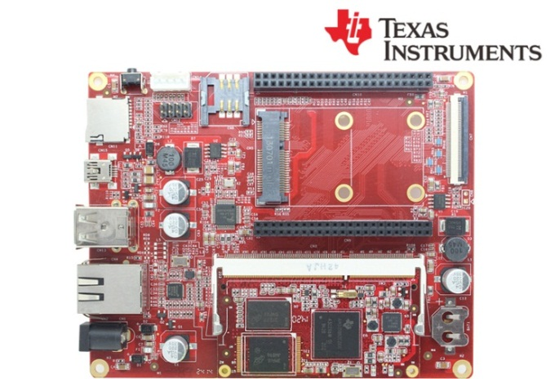](http://www.goembed.com/index.php/Products/detail/tpid/12)

*SBC335x – B2A*

The single board computer SBC335x-B1A/B2A which has an expansion board to carry the CM335X is one of our design of the base plate . The flexible design allows the fast and easy way of realizing and upgrading the controller’s capabilities. In additional to those features offered by CM335X.

The B1A features 4 serial ports (including 2 RS232 and 2 TTL), 4 USB Host and 1 USB OTG, 1 Ethernet ports, CAN, RS485, Wiegand, VGA, LCD, Touch screen, Audio, ADC and more other peripherals.

The B2A features 4 USB Host and 1 USB OTG, 1 Ethernet ports, LCD, Touch screen,RTC, and more other peripherals.

The SBC board targets a wide range of applications, including: HMIs, Digital Signage, POS, Data Terminal, Medical Devices, Navigation, Industrial Automation, Entertainment system, Thin Clients, Robotics, Game Console and much more.

The SBC335x-B1A/B2A are ready-to-run platform to support Linux 3.x, Android 4.x and WinCE 7.0/6.0 operating systems.

If you want to support other Operating System, For more information to contact us.



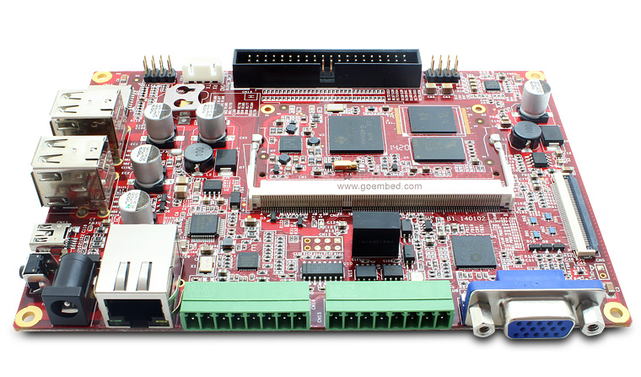

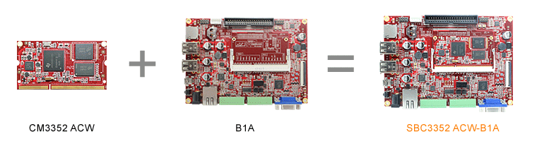

**SBC335x-B1A boards Description of part code:**

|  |  |  |  |  |
| --- | --- | --- | --- | --- |
| **Series** | **B1** | **B1** | **B1** | **B1** |
| **Part Code** | SBC3352 ACW-B1A | SBC3352 BCW-B1A | SBC3358 ACW-B1A | SBC3358 BCW-B1A |
| **Order Code** | - | - | - | - |
| **Core Module** | [CM3352 ACW](http://goembed.com/index.php/Products/detail/tpid/14)  [-M51E20/08](http://goembed.com/index.php/Products/detail/tpid/14) | [CM3352 BCW](http://goembed.com/index.php/Products/detail/tpid/29)  [-M51E40/08](http://goembed.com/index.php/Products/detail/tpid/29) | [CM3358 ACW](http://www.goembed.com/index.php/Products/detail/tpid/44)  [-M51E20/10](http://www.goembed.com/index.php/Products/detail/tpid/44) | [CM3358 BCW](http://goembed.com/index.php/Products/detail/tpid/22)  [-M51E40/10](http://goembed.com/index.php/Products/detail/tpid/22) |
| **CPU Type** | ARM Cortex™-A8 | | | |
| **CPU Cores** | 1x | | | |
| **CPU Clock** | 800MHz | 800MHz | 1.0GHz | 1.0GHz |
| **RAM DDR3** | Micron 512MB@16bit*1 | | | |
| **eMMC Flash** | 2GB@8bit*1 | 4GB@8bit*1 | 2GB@8bit*1 | 4GB@8bit*1 |
| **PMU** | TI TPS65910A3 | | | |
| Supply Voltage | DC 9-14V | | | |
| Optimal Input | DC 12V,1.5A | | | |
| **Size(L*W)** | 146 x 102 mm | | | |
| **Temperature** | 0° to 70° C | | | |
| **Support OS** | Linux 3.x/ Android 4.x/ Ubuntu/ Angstrom/ Debian/ QT/ WinCE 6.0/7.0 | | | |
| **Inventory status** | In Stock | **Out of Stock**  [**Contact us**](mailto:%20sales@goembed.com) | In Stock | **Out of Stock**  [**Contact us**](mailto:%20sales@goembed.com) |
| **Minimum Availability** | 2022 | | | |

**SBC335x-B1A Block Diagram**

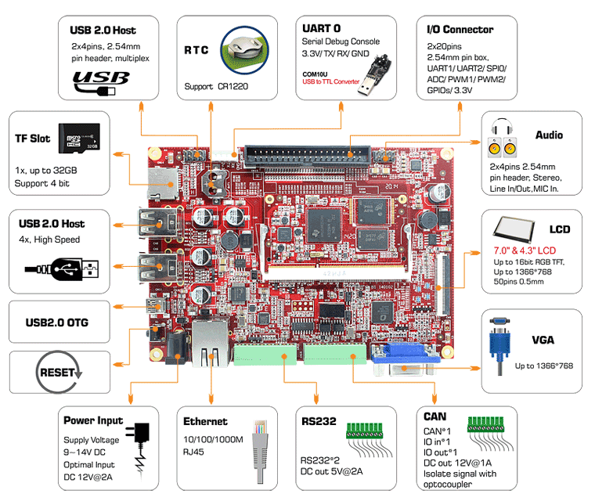

Figure 1 B1 Block Diagram



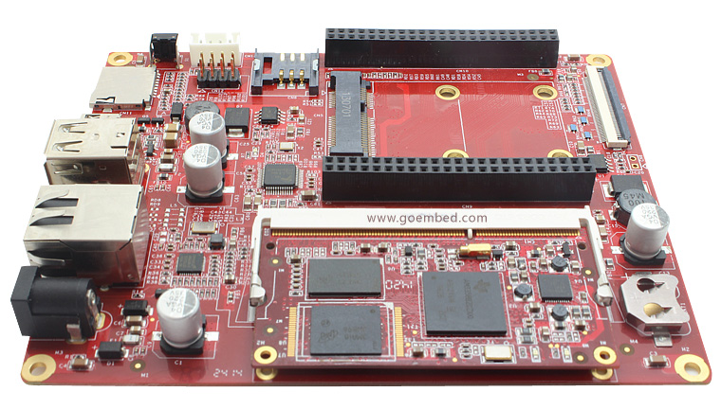

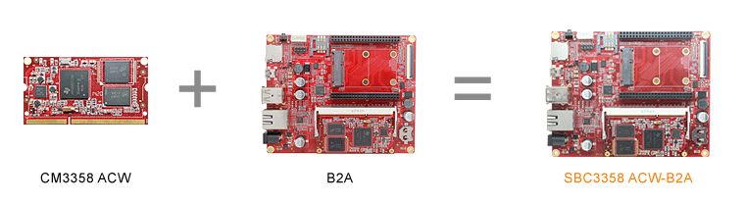

**SBC335x-B2A boards Description of part code:**

|  |  |  |  |  |
| --- | --- | --- | --- | --- |
| **Series** | **B2A** | **B2A** | **B2A** | **B2A** |
| **Part Code** | SBC3352 ACW-B2A | SBC3352 BCW-B2A | SBC3358 ACW-B2A | SBC3358 BCW-B2A |
| **Order Code** | - | - | - | - |
| **Core Module** | [CM3352 ACW](http://goembed.com/index.php/Products/detail/tpid/14)  [-M51E20/08](http://goembed.com/index.php/Products/detail/tpid/14) | [CM3352 BCW](http://goembed.com/index.php/Products/detail/tpid/29)  [-M51E40/08](http://goembed.com/index.php/Products/detail/tpid/29) | [CM3358 ACW](http://www.goembed.com/index.php/Products/detail/tpid/44)  [-M51E20/10](http://www.goembed.com/index.php/Products/detail/tpid/44) | [CM3358 BCW](http://goembed.com/index.php/Products/detail/tpid/22)  [-M51E40/10](http://goembed.com/index.php/Products/detail/tpid/22) |
| **CPU Type** | ARM Cortex™-A8 | | | |
| **CPU Cores** | 1x | | | |
| **CPU Clock** | 800MHz | 800MHz | 1.0GHz | 1.0GHz |
| **RAM DDR3** | Micron 512MB@16bit*1 | | | |
| **eMMC Flash** | 2GB@8bit*1 | 4GB@8bit*1 | 2GB@8bit*1 | 4GB@8bit*1 |
| **PMU** | TI TPS65910A3 | | | |
| Supply Voltage | DC 9-14V | | | |
| Optimal Input | DC 12V,1.5A | | | |
| **Size(L*W)** | 130 x 103.5 mm | | | |
| **Temperature** | 0° to 70° C | | | |
| **Support OS** | Linux 3.x/ Android 4.x/ Ubuntu/ Angstrom/ Debian/ QT/ WinCE 6.0/7.0 | | | |
| **Inventory status** | In Stock | **Out of Stock**  [**Contact us**](mailto:%20sales@goembed.com) | In Stock | **Out of Stock**  [**Contact us**](mailto:%20sales@goembed.com) |
| **Minimum Availability** | 2022 | | | |

**SBC335x-B2A Block Diagram**

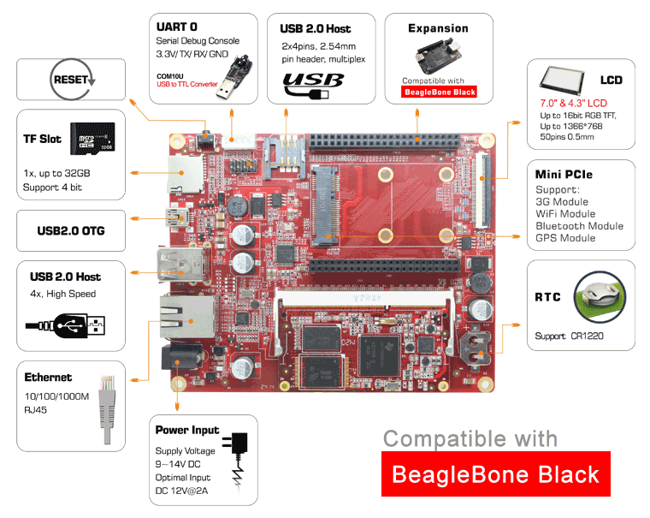

Figure 1 B2A Block Diagram

**ABOUT GOEMBED**

GOEMBED team with experienced embedded engineers who have been engaged in ARM hardware and software design for 10+ years.

Our products include single board computers and CPU core modules based on TI ® Sitara and Freescale ® i.MX Applications Processors based on ARM® Cores. Supported by Linux / Android / Debian / Ubuntu / QT / Angstrom / WinCE 7.0 & 6.0 / uCOS. We can redesign carrier boards and SBC as your idea quickly.

GOEMBED focus on Embedded Board Solutions, provide a complete new board for your specified requirement or even a turnkey solution to accelerate your new products to market.

We are your trust worthy partner on ARM embedded design services and solutions.

**More Carrier Boards**

Customized based on your needs!

**ODM / OEM Services**

Bring your new products to market quickly

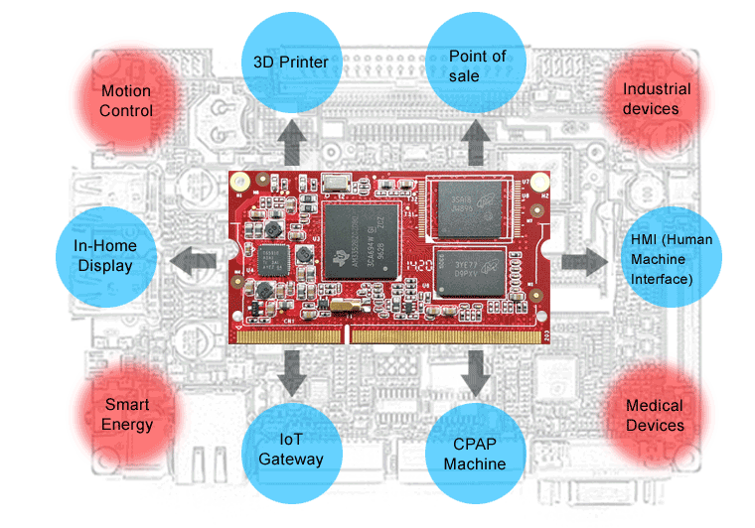

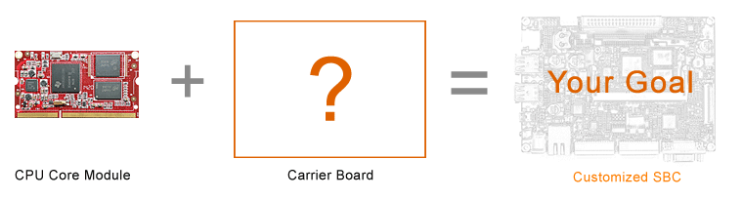

**Related end equipment**

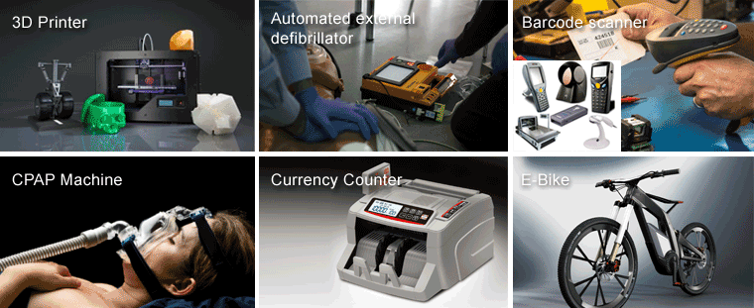

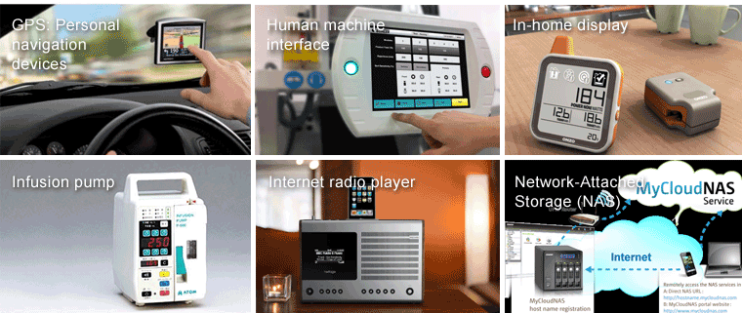

 Learn more applications please click <http://www.ti.com/lsds/ti/apps/appshomepage.page>

